**Amrita School of Engineering, Bengaluru**

**Amrita Vishwa Vidyapeetham**

**Course: 19PHY113/Computational Engineering Mechanics - 2**

**Course Instructor: Mr. Rajeevlochana G. Chittawadigi (Dept. of Mech. Engg.)**

**Course Project: Position, Velocity and Static Force Analysis of Planar Mechanism**

|  |  |
| --- | --- |
| **Team No. and Members** | **Project Details** |
| BL.EN.U4AIE190**13**  **Charan Tej K**  BL.EN.U4AIE190**14**  **Chavali Surya Teja**  BL.EN.U4AIE190**53**  **Rama Sai Abhishek P** | <https://www.dmg-lib.org/dmglib/main/portal.jsp?mainNaviState=browsen.manim.viewer&id=504022> |

**Submitted by: Ch. Surya Teja**

**INTRODUCTION**

Computational Engineering Mechanics deals with the basic concepts and techniques of kinematics and kinetics, their applications in real-life verticals, such as robotics. It focusses on both mathematical modeling and numerical simulation of solids.

This subject mainly explores the concepts initially through computational experiments with the help of the concept/theory behind it.

The course provides a connection between concepts of mechanics, mathematics, and computational thinking. Computational mechanics is the trisection of mechanics, applied mathematics, and computer science, which is aimed at developing new methods for solving computationally- challenging problems in science and engineering.

**Importance:**

The course mainly helps us to perceive the engineering problems using the fundamental concepts in kinetics and kinematics. This lays down a fundamental role in developing mechanisms to build robots.

A student needs to know the applications of mechanics in the real-life world. One should understand how to model engineering problems from the perspective of mechanics.

**DESCRIPTION OF THE PROJECT**

**What is a mechanism and how does this link to a machine?**

A mechanism is a series of bodies, assembled in such a way that the motion of one body causes constrained and predictable motion to others.

A mechanism transmits and modifies a motion. Something which is a combination of mechanisms that m apart from imparting definite motions to the parts also transmits and modifies the available mechanical energy into some kind of desired work is called a machine.

Thus, compared to a machine, a mechanism is a simplified form, where the exact shape of the link is not considered and a machine can have one or more inter-connected mechanisms.

So, the mechanism that we are going to be discussing in this area is known as ‘**Koppelkurven – Rastgetriebe**’ meaning coupling curves.

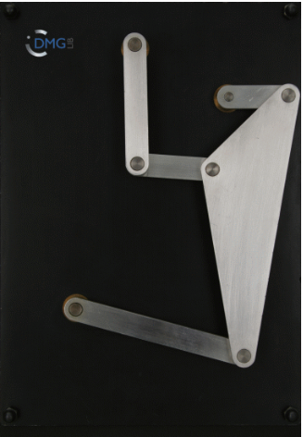

**(Figure 1)**

This is a planar mechanism, consisting of 6 links and 7 joints.

The degree of freedom of this mechanism is 1 when calculated using the Grubler’s formula.

**Grubler’s Equation :** DOF = [ 3*(N-1) – 2*() – ], where,

N No. of links.

No lower pairs.

No higher pairs.

Since we have 6 links, 7 revolute joints and no higher pairs,

the degree of freedom of the above mechanism comes out to be:

D.O.F = [ 3*(6-1) – 2*(7) – ]

= [ (3*5) – 14 ]

= 15 – 14

⇒ D.O.F = 1

* In physical terms, Degrees of Freedom of a system is defined as the no. of **INDEPENDENT** parameters or variables, required to define a system uniquely.
* Degrees of freedom of a machine is very important since it governs the working of a machine. When we observe any mechanism, we notice that each link in a mechanism can move in certain directions or rotate about certain axes and is **NOT** allowed to move or rotate in other directions.
* Degrees of Freedom determine the possible movements of mechanisms.
* So, if we consider the above mechanism, we see that the only possible parameter that we give as an input is rotation at the crank (clockwise or anti-clockwise).

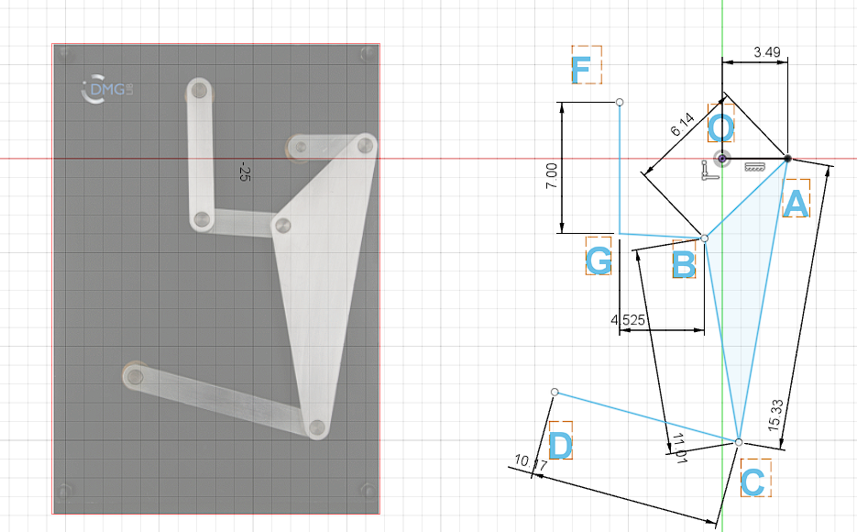

**(Figure 2)**

As mentioned before, the analysis of mechanisms is the study of motions and forces, concerning their different parts.

So, to understand better about the functioning of a mechanism, we dive into three main analyses – Position Analysis, Velocity Analysis, and Static Force Analysis, which we’ll be discussing in the latter.

**COMPUTATIONAL GEOMETRY**

**What is a parametric form of a line?**

When a particle is moving along a line, in a way such that it depends on a parameter t, the **parametric form** a line is considered.

When Cartesian coordinates of a curve or a surface are represented as functions of the same variable (usually written t), they are called the **parametric equations**.

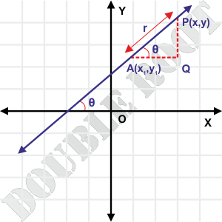

**(Figure 3)**

Let the distance from A to Q be ‘f’.

and the distance from Q to P be ‘g’.

As we see, from the above image, considering:

A = Co-ordinates of the starting point

P = Co-ordinates of the point P

f = Distance from A to P along X-axis.

g = Distance from A to P along Y-axis.

When we write the coordinates of P, we get,

*x* = + f

= *y =* + g …… **(1)**

Now, let's suppose, the length of AQ and QP have been doubled.

Therefore, we can write the co-ordinates of P as :

*x* = + 2f

= *y =* +2g ……..**(2)**

Thus, we conclude by saying that the distance along the x-axis and y-axis is varying from the initial point. So, the generalized form of those equations would be,

*x* = + *t*\*(f)

= *y =* + *t*\*(g) ……..**(3)**

Where ‘t’(a scalar quantity) is a parameter that changes for every point.

This equation **(3)** is also known as the ‘**Parametric Equation’** of a line.

**Line – Line Intersection:**

Considering the figure below, let's say suppose there are two vectors along with AB and DC , respectively.

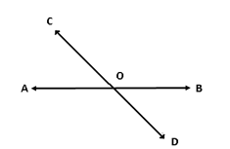

**( Figure 4 )**

So, as discussed previously, their parametric form of the line can be written as :

= )

= + *t* * ( )

As O is the intersection point if these two lines, the above two equations can be written as:

**=**

When written in AX=B (linear algebra form), we get,

(from figure 3)

⇒

Taking this in the form Ax = B,

By calculating the determinant of , we get,

* If det () = 0, the lines are parallel and co-incident.
* If det () > 0, det () < 0 lines intersect with each other.

**Line-Circle Intersection:**

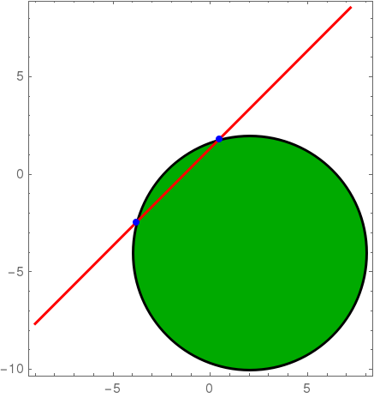







**( Figure 5 )**

Parametric Equation is used to represent the intersection between a line and a circle.

Let the center of the circle be (, ,) and the line AB is passing through the circle. Points X and Y are the intersections of the line AB with the circle. is a vector along the line AB.

Assuming, the point of intersection as P, The parametric form of line and circle is represented as,

…….(1)

………(2), is the angle w.r.t to the x-axis of every point on the circle.

Since circle and line meet at point P, we can write (1) and (2) as,

From the above equation, we can find that there are two parameters t and . We are using quadratic equations, to solve the following.

( ………(3)

………(2)

For eliminating theta, both the equations are to be squared and added after which we get, an equation in terms of t, and :

Finally, we conclude that:

Discriminant > 0, we get two distinct points.

Discriminant < 0, the line and the circle do not meet anywhere.

Discriminant = 0, the line becomes a tangent.

**Circle-Circle Intersection:**

The parametric equation is also used to portray the circle-circle intersection.

At first, the intersection is taken, normally by joining two circles.

As given in the figure.6, and we aim to find the common point of the given two circles. We then continue to extend the line p2 – p3 on either side till the intersection points (here, the common point is p2). We find the intersection points by determining the slope of the line p3-p2-p3.

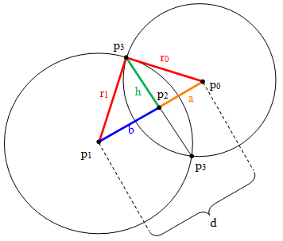





**( Figure 6 )**

We then calculate the points, by the line-circle method:

|p1-p3| (**∵** b+a = d , as mentioned in the figure).

also,

|a| = |d|-|b|,

where and are the radii of the circle A and circle B respectively.

Thus, the parametric equation of the line p3-p2-p3 is :

where ‘m’ is the slope of the line

**POSITION ANALYSIS**

Coming to the Position Analysis, it deals with the study of the orientation of the mechanism. It gives us an overview of the constraint and moving links present in the mechanism.

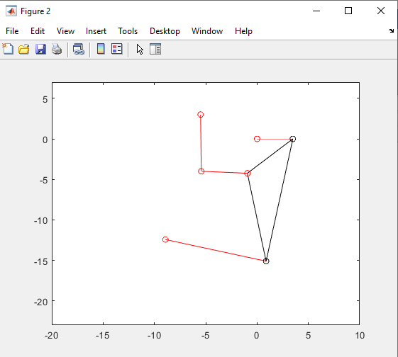



**(Figure 8 – Website’s Image)**

**( Figure 7 – Done in MATLAB )**

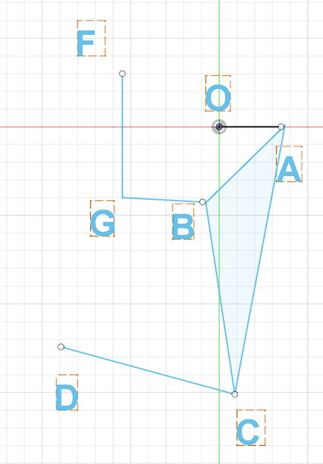If we observe that, the circle-circle intersection function has been used many times in plotting the mechanism in MATLAB.

We get two intersection points in Circle-Circle Intersection.

The Circle-Circle Intersection function returns two values (the intersection points) and accepts 4 parameters – the center of the 1st circle, the radius of it, the center of the 2nd circle, and the radius of it).

For example, as you compare figures 9 and 7, **(Figure – 9)** we see that for plotting point C we take the intersection points of the two circles by considering their respective radii with the help of Circle-Circle Intersection function. In MATLAB we give the input like this:

[pointC1, pointC2] = CircleCircleIntersection(point, lengthAC, pointD, lengthDC);

Out of which, only one intersection point is taken depending on our desired direction.

Similarly, using the above method, we plot the points B and G.

**Sample screenshots of for different values of input joint motion:**

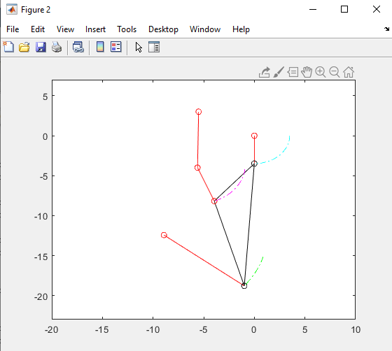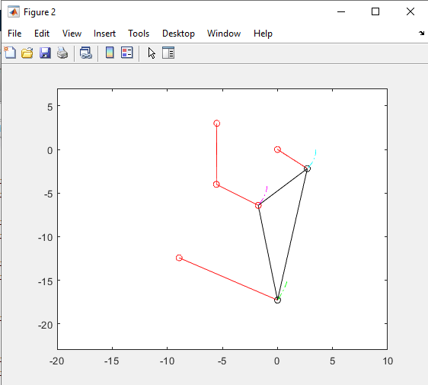

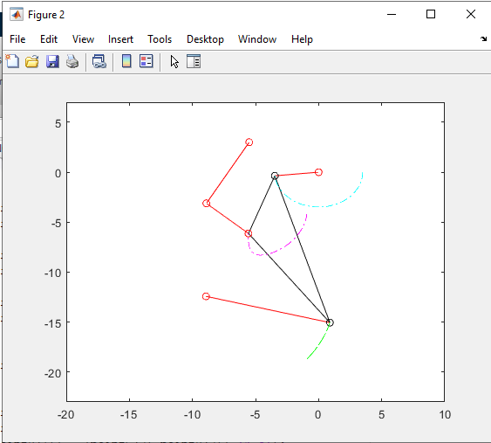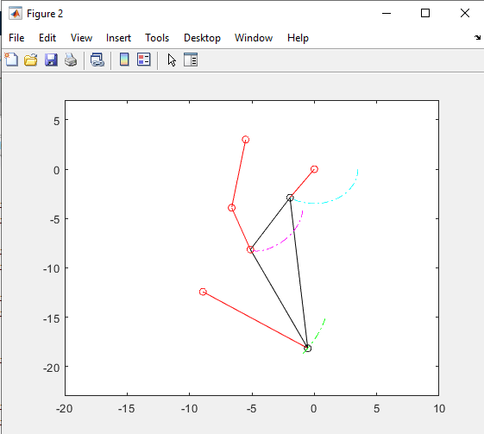 **(** **Figure 10 ) (** **Figure 11 )**

**(** **Figure 12 ) (** **Figure 13 )**

**Trace:**

The figure below shows the complete trace for revolute joints ,

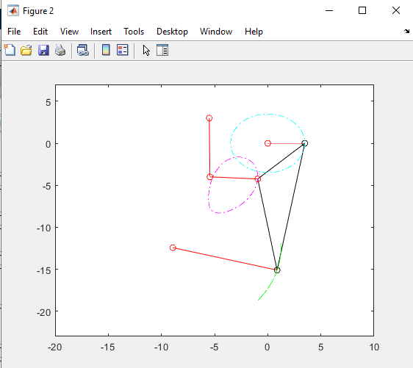and ,

**(Figure 14)**

**VELOCITY ANALYSIS**

The study of velocity analysis involves the linear velocities of various points on different links of a mechanism.

The velocity analysis is a pre-requisite for acceleration analysis, which further leads to force analysis of various links of a mechanism.

In this, we mainly use Lines - Intersection Function and Circle-Circle – Intersection function.

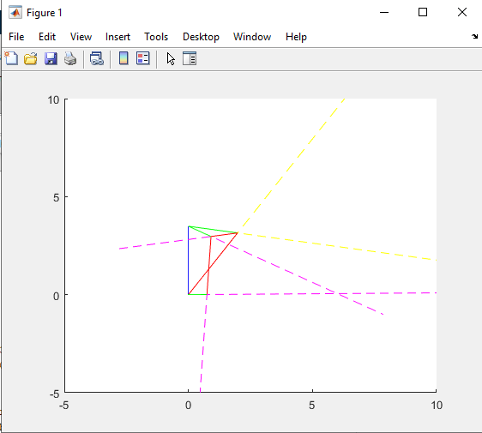

**(Figure 15)**

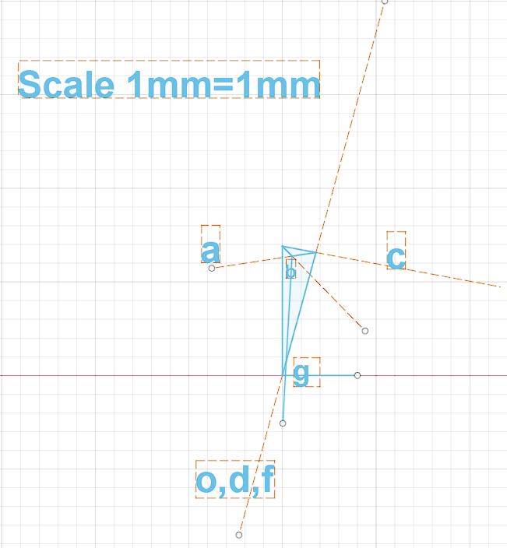 The lines intersection function basically, finds the intersection of 2 lines.

It accepts four parameters, namely – the origin point of 1st line, the direction of that line towards the resultant intersection point, the origin point of the 2nd line, and its direction towards the resultant intersection point.

**(Figure – 16)**

So, for example for finding point ‘c’ in the above velocity analysis (figure - 16) the code would look like this :

pointc=LinesIntersection(pointa,dirOfAC_Per,pointo,dirOfDC_Per)

where point a is the starting point of ac and point o is the starting point of dc and their respective directions.

As discussed above, the Circle-Circle Intersection function is again used to draw the configuration diagram, to sketch the velocity polygon.

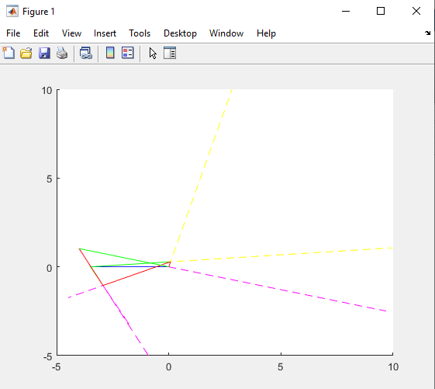**Sample screenshots of velocity polygon with different input joint angles:**

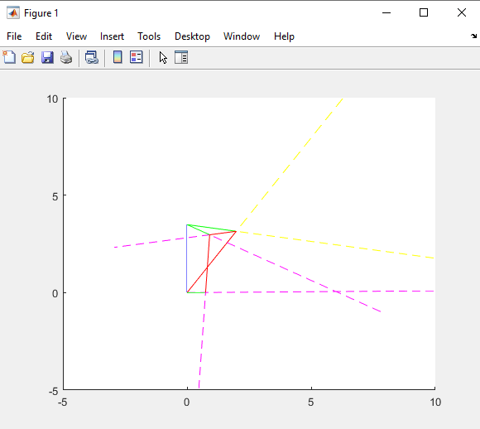

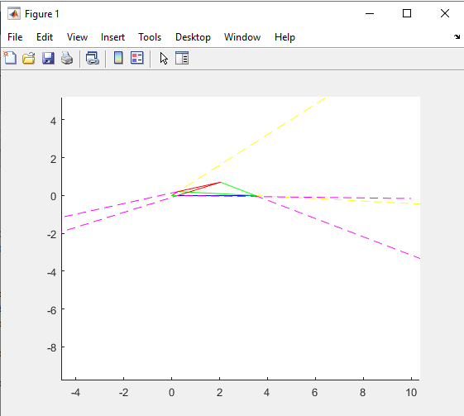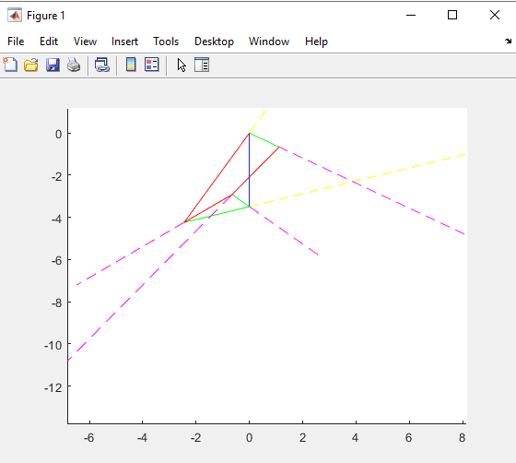**(Figure 17 - ) (Figure 18 - )**

**(Figure 18 - ) (Figure 18 - )**

**STATIC FORCE ANALYSIS**

Static force analysis makes direct use of static force equilibrium equations.

For an analytical solution formulation, one must draw the free-body diagram of each rigid body and must identify the unknown forces.

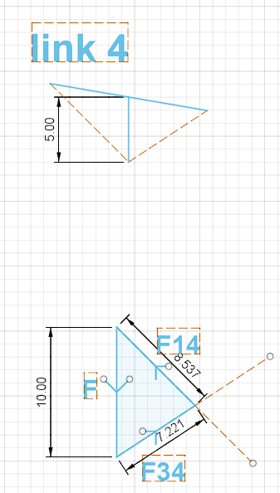 The figure shows the FBD of link 4 and its respective force polygon.

The external force of F = 10 N has been applied vertically downwards on to link #4.

As we see here, link #4 is the farthest link from the crank.

As the magnitude of the forces other than F is not known, we use the Lines-Intersection function to calculate.

As explained above, this function takes 4 parameters.

**(Figure 19)**

With the help of this function, we get the magnitudes of the forces F14 and F34 respectively.

Similarly, the FBD’s of all the links have to be drawn and the reaction forces have to be calculated.

To maintain static equilibrium, we need to apply the moment on the crank, in the opposite direction to that of the motion.

First, to calculate the moment, with the help of static force analysis, we find the magnitude of the reaction forces acting on the crank.

We know that,

Moment = Force x (Perpendicular Distance between the forces)

As calculated from the above analysis, we find the magnitudes of the force to be 9.993 N and the perpendicular distance to be 1.338

So, moment on the crank due to external force F = 9.993 * 1.338

= 13.37 N(mm).

To counter this moment we have to apply -13.37 N(mm) in the same direction to maintain the static equilibrium.

**Sample screenshots of free Body Diagrams and results obtained in MATLAB:**

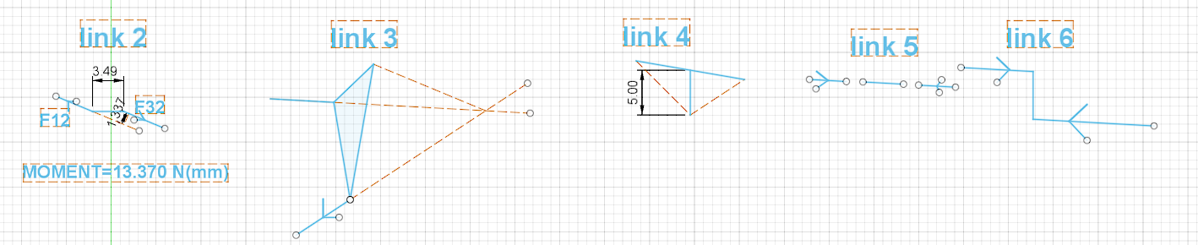

**(Figure 20)**

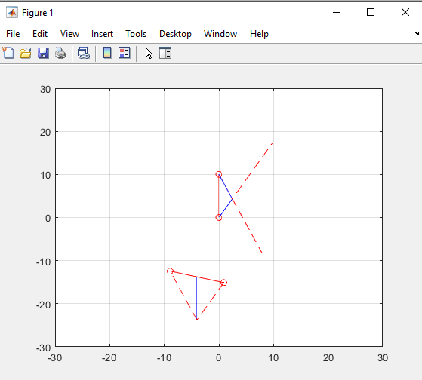

**(Figure – 21)**

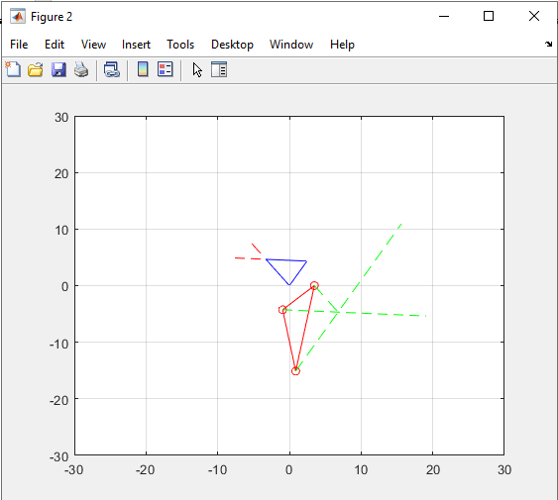

**(Figure -22)**

**CONCLUSION**

This project mainly explains the 3 main analyses required for any mechanism to be applied in the field of robotics.

The purpose of this is to get an overview of what exactly happens with a mechanism.

If we see that every analysis that we discussed has individual importance of its own:

* Position analysis is very useful in knowing the input and output position parameters and can also help in a detailed understanding of different applications.
* Velocity analysis involves the linear velocities of various points on different links of a mechanism which helps us to design proper models for different applications.
* Static force analysis helps in selecting the proper size of machine components to withstand the stresses developed in them. These proper sizes are not selected, the components may fail during the machine operations.

We, as in the whole team understood the importance of mechanisms and their role in building a machine. These all put together, form the fundamental concepts for Robotics.